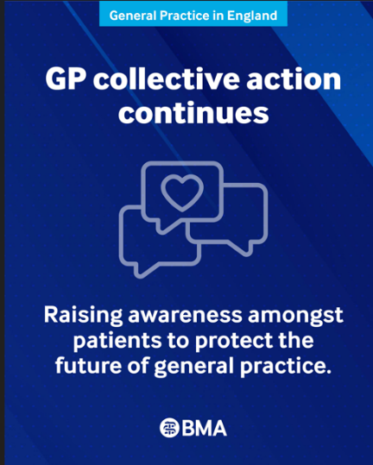
Dear colleagues

GP collective action and escalation plan
GP collective action continues this September. Following our steady monthly additions, we have decided to maintain all existing actions this month rather than escalating further.

This decision creates the opportunity for the newly elected GPC England officer team to build on positive initial discussions with Amanda Doyle, National Director for Primary Care and Community Services (NHSE). Our priority is to secure written confirmation from the Government agreeing to formal bilateral negotiations prior to our next committee meeting on 17 September. In preparation, the GPCE committee will still discuss a comprehensive escalation plan on 17 September, should Government fail to deliver sufficient reassurances.

Practices can continue to support the campaign by helping patients understand the pressures facing general practice, why change is needed and how they can support their local practice. By now, practices should have received a package of posters as part of our August collective action. There are also leaflets in different languages that you can order from the BMA website, as well as short films to display on your reception screens, and graphics add to your practice website, available to download here.

We also encourage practices to support our public campaign by signing and sharing the public petition with patients.

Finally, we would encourage practices to write to your MP using our online tool and explain directly the pressures your practice is facing.

Read more about the other collective actions from the GP campaign webpage

Neighbourhood arrangements
The consultation on proposed Multi-Neighbourhood Provider (MNP) and Single Neighbourhood Provider (SNP) contracting models to support neighbourhood closes next week on 10 September. Neighbourhood models have the potential to have a significant impact on general practice, and we are already seeing a number of initiatives taking place across England. It’s therefore important to that practices and LMCs ensure that their views heard by responding to the consultation.

We would like to again remind practices that they do not have to, and should not be pressured to, sign up to local neighbourhood proposals. There must be full and meaningful engagement with practices and LMCs to ensure there is appropriate governance in place as well as ring-fenced budgets for key areas especially around resourcing left shift of work, protections around sharing confidential data and proper utilisation of estates. Read our guidance

Semaglutide for cardiovascular risk reduction
The introduction of semaglutide for cardiovascular risk reduction is a welcome and important development, with clear evidence demonstrating a reduction in major cardiovascular events. However, its implementation must be supported by appropriate funding, commissioning, and infrastructure. General practice should not be expected to deliver this work within existing resources. Read our guidance

GP pressures
In July 2026 the NHS employed the equivalent of 29,057 fully qualified full-time GPs – a slight increase from the previous month (29,008). Despite the GP workforce growing, there are still 307 fewer fully qualified FTE GPs than in September 2015.

During this time, there has been a rise in the number of patients. GPs employed by practices are now responsible for about 12% more patients than in 2015, demonstrating significant workload pressures. There is also an increase in appointments, with 34 million standard appointments delivered in July 2026 – an average of 1.48 million appointments per working day.

Read more about the pressures facing general practice.

Report into use of Advice and Guidance (A&G) referrals
As mentioned in the previous bulletin, HSSIB’s report on the use of A&G referral services in England found evidence that patients were harmed when hospital referrals were pushed back instead of accepted.
Since the imposition of the 2026 contract that further embedded the use of A&G in General Practice, we have repeatedly raised issues with its implementation, and this report vindicates those concerns, showing that patients have come to harm as a result of a rushed-out and inconsistently applied process.

We continue to argue for an urgent review of a system that is putting patients at risk.

NHS Community Pharmacy Hypertension Case-Finding Service – referrals from practices
Changes to the service are being made from 3rd September 2026, with amended patient eligibility criteria that focus principally on hypertension case-finding. The key changes affecting general practice are:

- Only patients without a prior diagnosis of hypertension and who have not had their blood pressure checked in the last 5 years can be referred/signposted by general practice for a clinic BP check.
- Ambulatory blood pressure monitoring (ABPM) can only be offered to adults who are aged 40 years and over. Practices can still refer patients with a pre-existing diagnosis of hypertension for ABPM.

Further information can be found in a Community Pharmacy England briefing document for practices.
- The BMA’s GP campaign webpage
- The GPCE Collective Action page
- GPCE Safe Working Guidance Handbook
- Read more about the work of GPC England and practical guidance for GP practices
- See the latest update on X @BMA_GP and read about BMA in the media

GPCE bulletin: GP collective action and escalation plan | neighbourhood arrangements | workforce pressures

Dr Shan Hussain
GPC England deputy chair

Email: info.lmcqueries@bma.org.uk (for LMC queries)
Email: info.gpc@bma.org.uk (for GPs and practices)

