Dear colleagues

Government commits to bilateral talks

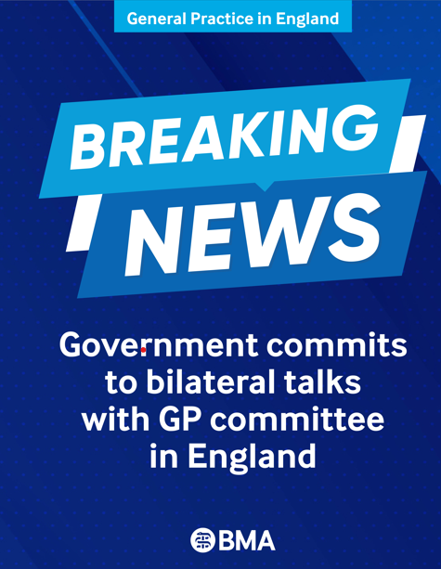
Our priority since July has been to secure written confirmation from the Government to agree to re-enter formal bilateral negotiations with us. We set a deadline for this, coinciding with a meeting of GPC England (GPCE) yesterday, 17 September.

The GPCE officer team has had a positive initial contact with ministers and civil servants, and I am pleased to say the Government has now agreed to return to formal bilateral discussions with us, and we are temporarily postponing any further escalation of collective action.

The committee was disappointed in the lack of Government commitment to ‘negotiations’ and were very clear they expect to see significant progress over coming months. However, although the committee voted to postpone further escalation, we will not stop highlighting the extraordinary challenges general practice is currently facing in all our forthcoming negotiations. Our practice teams continue to deliver outstanding care despite the relentless pressures we encounter, and we must ensure we do so safely for ourselves and our patients. We will soon be relaunching our safe working guidance and urge you to continue using it.

In entering these negotiations, our focus remains on securing a confirmed roadmap with the Government for a £50 per patient increase in core practice funding and clarity on turning unsafe demand into manageable care for our patients. This is a golden opportunity to reset relations and trust with the profession that Government ministers must now heed. Over the summer we have developed a clear escalation strategy and that has been supported by the committee. We are clear that we remain in formal dispute in the meantime over an imposed April 26 contract and practices should continuecurrent actions, but if insufficient progress is made in discussions with Government at any point, we will escalate collective action, which will be worked upon in the background during talks with the government.

Thank you for your continued commitment and activism for the collective cause of all GPs and our patients.

Read more on the GP campaign webpage

A reminder that our public petition to support general practice remains open – please sign and encourage patients to do so too.

AI triage pilots via the NHS app
We are aware that requests for expressions of interest have been going out to some areas to ask practices and PCNs (from 20,000 to 100,000 patient populations) to pilot AI-assisted triage within the NHS app. Future AI use within the NHS app was mentioned at the launch of the 10 Year Health Plan last year (Managing healthcare easy as online banking with revamped NHS App - GOV.UK) where phrases like "My NHS GP" and a "doctor in your pocket" were used along with the use of AI to provide "instant advice" to patients. The Joint GP IT Committee previously fed back to NHS England about the poor choice of words to describe such a tool. Until the regulatory landscape is firmly established around such AI tools and they are proven to be safe, and any effect on longer-term funding is known, we would caution practices against involvement.

Help Shape the Future of Health Data Policy
The Department of Health and Social Care is continuing to recruit GPs to take part in a national engagement programme exploring how patient data is used for individual care, NHS planning and commissioning, and health-related research. There is a final series of three online workshops from 6-8.30pm on 21 September, 28 September and 5 October. This is an opportunity to influence decisions at a national level that will shape how patient data is used in the future.

Join the GP registrar committee
The elections for the 2026/27 session of the BMA’s GP registrar committee have now concluded. However, the following regional seats remain vacant:

- Scotland South East
- Northern Ireland
- Lancashire (North West Deanery region of North West LETB)
- London North East and Central

We’re currently looking for enthusiastic representatives to fill these positions and help complete the committee. All regional roles will run for two sessions, from 2026 to 2028.

Please share this with any GP registrars in your region who may be interested, and send an expression of interest to gpregistrars@bma.org.uk
- The BMA’s GP campaign webpage
- The GPCE Collective Action page
- GPCE Safe Working Guidance Handbook
- Read more about the work of GPC England and practical guidance for GP practices
- See the latest update on X @BMA_GP and read about BMA in the media

GPCE bulletin: News: Government commits to bilateral discussions

Dr Clare Bannon
GPC England chair

Email: info.lmcqueries@bma.org.uk (for LMC queries)
Email: info.gpc@bma.org.uk (for GPs and practices)

