Dear colleagues
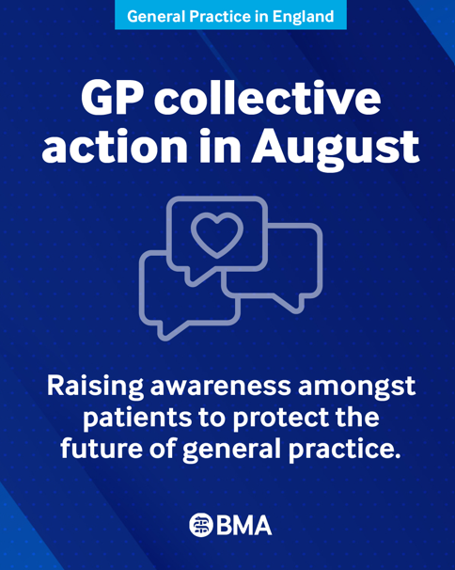
New collective action for practices for August

Our collective action continues in August. Alongside the existing actions, we are now asking practices to help bring patients on board by explaining the pressures facing general practice, why change is needed and how they can support their local GP practice.

We’re sending practices a set of posters by post, along with a range of digital materials that you can download and share, including leaflets that you'll be able to order in a range of different languages. These resources are designed to help patients understand that GPs want the same things they do: safe and sustainable general practice that delivers high-quality care for everyone. Practices should receive these materials late next week or early the following one. We would appreciate if LMCs could encourage local practices to use the materials.

We have launched a major new public petition to show support for general practice and call on the Government to act. Please sign it today and encourage your patients to add their voices too.

In addition, we would encourage practices to write to your MP using our online tool and explain directly the pressures your practice is facing. Hearing directly from GPs will help MPs understand the impact of continued underfunding on practices and patient care, and strengthen our case in negotiations with the Government for the investment and contractual changes general practice urgently needs.

Collective action is not stopping. The GPC England officer team is exploring options of escalation of collective action in the coming months.

Taking part in this and any future collective actions will help keep your practice safe. These actions are lawful, straightforward to implement and do not breach your contract. The new Government and health minister have an opportunity to reset relations with the profession, and the door remains open to meaningful negotiations. However, we will continue to press for the changes general practice needs if our concerns are not addressed.

Read more about taking collective action and access our resources on taking part in collective action.

Collective action: July onwards
During July, we asked practices to refuse all new requests for shared care where these are not appropriately resourced. Shared care arrangements are voluntary, and GPs and practices should not accept new informal arrangements and should only enter them where terms are clear, clinically safe, and adequately resourced. Read our guidance Action on shared care responsibilities for new patients in general practice

Collective action: June onwards
During June, we asked practices to remove or ignore any non-contractual medicines optimisation software and amend the choices of acute prescription, which may fall outside the remit of the ICB formulary. This may include issuing a branded or liquid formulation that may still be a perfectly acceptable and justifiable choice for the care of the patient in front of you in the consultation.
Read our Focus on guidance on Switching off medicines optimisation software

Collective Action: May onwards
Central to the ongoing collective action that began in May was practices sending a letter to their ICB:
asking them to assess each existing DSA your practice is currently signed up to while indicating you will stop agreeing to voluntary secondary uses data sharing agreements (DSAs). Access our two template letters on our resource page on Collective Action.

Post-exposure vaccination for Rabies
We are continuing to meet with NHS England and UKHSA to discuss the approach to post-exposure vaccination and treatment of potential Rabies cases.

Under the definition of vaccination services set out within the Regulations, we do not believe that GP provision of post-exposure rabies vaccination is a specific contractual requirement, although in some areas there may be local agreements in place to contract and fund this work, outside of national GMS arrangements. As with any services provided under the broader definition of essential Services, it is up to the practice to determine how that should be delivered, including referral to more appropriate speciality services (see further guidance).

Similarly, there may be occasional requests for practices to provide irrigation of wounds with human rabies immunoglobin (HRIG). This requires appropriate training/experience to minimise the potential for patient harm, and we believe that this should be referred to an appropriate service.

Neighbourhood arrangements
We are aware that in many areas practices may be feeling under pressure to agree to new neighbourhood working models, and with the announcement of the consultation on neighbourhood models, there is increasing uncertainty and concern. We would like to reassure practices that they do not have to, and should not be pressured to, sign up to local neighbourhood proposals. There must be full and meaningful engagement with practices and LMCs to ensure there is appropriate governance in place as well as ring-fenced budgets for key areas especially around resourcing left shift of work, protections around sharing confidential data and proper utilisation of estates.

Read our update and watch a video on X by the GPC England chair, Dr Clare Bannon.

GP appointments and workforce data
In June 2026, NHS employed the equivalent of 29,008 fully qualified full-time GPs. Despite a slight rise in numbers since 2023, GP practices still employ 356 fewer fully qualified FTE GPs than they did in 2015. There has also been a decrease of 1,474 practices, whilst patient numbers have continued rising: as of June 2026, 63.4 million patients were registered with practices in England – an average of 10,316 per practice. As a result, each full-time equivalent GP is responsible for an average of 2,187 patients; an increase of 249 patients per GP since 2015.

Read more about the pressures facing general practice.

Ensuring the efficient supply and distribution of medicines to patients
The Department for Health and Social Care has published a guidance document Ensuring the efficient supply and distribution of medicines to patients. This sets out best practice to ensure the efficient supply of medicines to patients and to minimise the risk of shortages. It does not place any new requirements on those who supply, procure or dispense NHS medicines.

The BMA, along with other stakeholders, has endorsed this guidance.

- The BMA’s GP campaign webpage
- The GPCE Collective Action page
- GPCE Safe Working Guidance Handbook
- Read more about the work of GPC England and practical guidance for GP practices
- See the latest update on X @BMA_GP and read about BMA in the media

GPCE bulletin: August collective action | rabies post-exposure vaccination | neighbourhood arrangements

Dr Manu Agrawal
GPC England deputy chair

Email: info.lmcqueries@bma.org.uk (for LMC queries)
Email: info.gpc@bma.org.uk (for GPs and practices)

