Dear colleagues

Collective Action & Collective Thank You
Three years ago, I set out with three simple demands of government: give us and our patients safety, stability and hope. We leave with much still to do, but with a profession that is more organised, more engaged and more informed than it has been for many years. In this week’s Talking General Practice podcast, I speak about my decision not to stand for re-election when our three-year term ends next week, and the highs and lows of an extraordinary three years for general practice, and what my departure may mean for the ongoing dispute with the government.
Together, we built the evidence base through engagement and surveys; published guidance, handbooks and our vision; reinstated DDRB evidence for GPs in England; oversaw a BMA membership cleanse of all records ahead of the first referendum in Spring 2024 where over 19,000 GPs voted 99% against the government’s contract imposition. This was followed by the online and in-person roadshows countrywide and the non-statutory ballot of GP contractors which gave us a 68% turnout of a 98.3% mandate to proceed. We saw 4000 new GP members join the BMA, secured the largest investment into GMS since 2004, and achieved unprecedented engagement from the profession, with tens of thousands of GPs participating in ballots, referendums and roadshows across England.
This month, you will receive our final piece of work: posters arriving in the post at your surgery for an open patient letter to government, highlighting how fragile continuity of GP care is without sustained further investment.
Alongside this, we produced documents which informed policy in all four nations, whilst seeking to equip practices with practical tools to survive and thrive: authoritative guidance spanning contracts, finance, safe working, AI, online consulting, data sharing, shared care, waiting lists, demand and capacity, premises, underemployment and much more; landmark surveys creating an enduring evidence base; and public campaigns reminding the nation of the extraordinary value of general practice.
This has been a team effort, impossible without my deputy chairs Samira Anane, David Wrigley and Julius Parker – not to mention the BMA staff and GPC England itself, with LMCs nationwide, and above all, you and the thousands of GPs who chose to engage, contribute and stand together. General practice remains under immense pressure, but it is no longer standing still. I leave confident that the strongest legacy of these past three years is a profession that has rediscovered its collective voice and its willingness to use it.
It has been the greatest privilege of my professional life to serve as Chair of the England GP Committee.
Thank you.
Dr Katie Bramall
GPC England chair

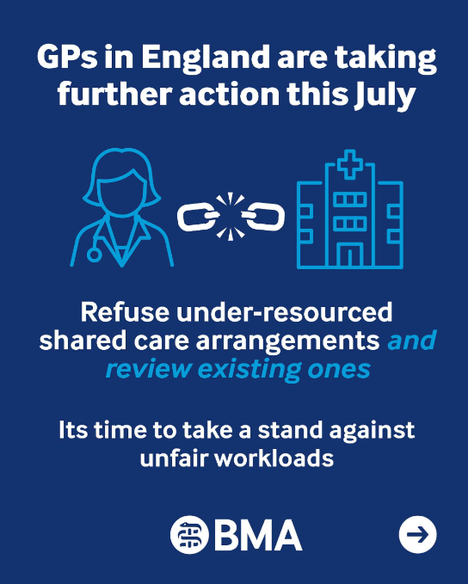
New collective action for practices in July – refusing new requests for shared care
We are asking GPs and practices to refuse all new requests for shared care where these are not appropriately resourced. GPs and Practices should not accept new informal arrangements and should only enter them where terms are clear, clinically safe, and adequately resourced. We also encourage practices to work with their LMCs and use this as an opportunity to review any existing arrangements, check that protocols remain up to date, clarify responsibilities, identify prescribing that takes place without formal agreements, and ensure that prescribing, monitoring and recall systems are robust and consistent.

Taking part in this action is lawful. Shared care arrangements are voluntary. GPs must only enter into them when they can provide care safely, have adequate resources, and have clear agreements in place that clearly set out responsibilities for everyone involved. Without these safeguards, practices will likely struggle to deliver shared care safely while continuing to meet the wider needs of their registered patients.

Practice action this month:
We are asking practices to raise your concerns about the current contract and the future of general practice directly with your local MP – who will shortly go into parliamentary recess for the summer and have more time in their constituency. It is the ideal moment for practices to co-ordinate a letter-writing campaign and we have tried to make this as simple as possible for you with our online tool.
You can use this tool to write to your MP and urge them to support their local practices by holding government to account. The letter calls on MPs to raise our concerns directly with government asking them to address the issues we have raised regarding safety, funding and data and demand they work with us to resolve them for our patients and the future of general practice.
Patient action this month:
Your practice will very soon be receiving copies of posters for your surgery reception, waiting rooms and consultation rooms inviting patients to sign an open letter to Government to invest in more GPs and better premises to guarantee the future of patients’ ability to access general practice. In essence the letter explains the increasing demand, where we see 1.5 million of the daily 1.7 million NHS total patient care; how we have lost 20% of practices since 2015; and the growing Doctor:Patient ratio from 1900 a decade ago, to 2,200 now. It highlights how GMS is funded at 36p per day per patient – less than the price of an apple. It calls on patients to support their GP practice in fighting for high quality continuity of care in a surgery you know, with a team you trust.

Resources:

Action on shared care responsibilities for new patients in general practice

Template practice letter to MPs about the future of general practice

Patient resources and practice campaign materials

Principles for Shared Care Prescribing.

Collective action: June onwards
During June, we asked practices to remove or ignore any non-contractual medicines optimisation software and amend the choices of acute prescription, which may fall outside the remit of the ICB formulary. This may include, for example, issuing a branded or liquid formulation that may still be a perfectly acceptable and justifiable choice for the care of the patient in front of you in the consultation. Read our Focus on guidance on Switching off medicines optimisation software

Collective Action: May onwards
Have you followed up with your ICB about data sharing?

Central to the ongoing collective action that began in May was practices sending a letter to their ICB:
asking them to assess each existing DSA your practice is currently signed up to while indicating you will stop agreeing to voluntary secondary uses data sharing agreements (DSAs).

Now send your follow-up letter. Thousands of practices have sent both, the two templates can be found on our resource page on Collective Action. If you’re yet to send yours - it’s not too late.

Access our resources on taking part in collective action

GPCE letter to ICBs re: FDP Data Sharing
GPC England sent letters to all ICBs on 1 July seeking urgent clarification on the extent of GP data use within local instances of the Palantir-powered Federated Data Platform. Following reports that GP data was being ingested at scale, GPCE is seeking to understand the basis on which this data is being used and what, if any, data sharing agreements are being used to underpin it. The letter and responses will provide better insight into how local data flows are being set up to support the FDP and enable practices to determine how best to protect the data of their patients.

Guidance for LMCs regarding preparatory IA activity
The Guidance for LMCs regarding preparatory IA activity has now been published on the BMA GPCE’s ‘How to take part in GP collective action in England’ web page (you can find it under the ‘Resources’ section towards the bottom of the page).

This is the guidance initially circulated in June 2023 and subsequently re-circulated in February 2024 and February 2026. If you have any questions or feedback, please email info.lmcqueries@bma.org.uk.

Help us build the case for CQC reform
GPC England is supporting our colleagues at RCGP to gather evidence from members about their experiences of CQC inspections and assessments. We have heard a range of concerns from GPs across the country, but we need a clearer understanding of how representative these experiences are and where the greatest challenges lie.

To help us do this, a short survey that should take less than 10 minutes to complete is linked below. The evidence you provide will be invaluable in informing collective discussions with the CQC, Government and wider system partners as reforms are developed. The more responses we receive, the stronger our case for change will be.

Oliver McGowan training
Concerns have been raised with us about the way that Oliver McGowan training is currently delivered. We know that GPs are committed to providing the highest standards of care to people with learning disabilities and autism, but reports from GPs suggest considerable inconsistency on the quality of training that is currently provided across the country, particularly given the importance of GPs using their time effectively. We have raised these initial concerns with NHS England. They are keen to understand the issues better and we will be discussing them further soon. We will keep the profession updated with any developments.

Safe working means learning to say 'no'

This week, the BMA’s Sessional GPs committee is focusing on your safe working rights and the steps you can take to protect your wellbeing while delivering high-quality patient care. In her latest blog, Jessica Court shares practical safe working advice and explains why it's so important to challenge workload demands when they become unsafe or unsustainable. We also encourage you to review our salaried and locum GP checklists to ensure you have the right protections and support in place.

- The BMA’s GP campaign webpage
- The GPCE Collective Action page
- GPCE Safe Working Guidance Handbook
- Read more about the work of GPC England and practical guidance for GP practices
- See the latest update on X @BMA_GP and read about BMA in the media

GPCE bulletin: Refusing new shared care requests | write to your MP tool | resources for patients

Dr Katie Bramall
GPC England chair

Email: info.lmcqueries@bma.org.uk (for LMC queries)
Email: info.gpc@bma.org.uk (for GPs and practices)

