Dear colleagues

New GPC England Officer team
We want to take this opportunity to introduce the new GPCE team. Many of you will already have seen the email and video from the new GPC England Chair, Dr Clare Bannon, that went out at the end of last week. Clare is now joined by Dr Manu Agrawal, Dr David Wrigley and Dr Shan Hussain as Deputy chairs of GPCE (see their information below). In our first week we have taken GPC England feedback on the way forward and view around collective action. We have all heard the calls for a clear ask and clear, strong, collective action. We will be meeting with NHSE, DHSC and Ministers over the coming weeks. Whilst we are clear this is an opportunity for a fresh start, we are also clear that General practice needs a substantial increase in funding, our initial ask is for £40 per patient per year alongside contract reform.

We will be consolidating the collective actions already in place with patient facing materials, being sent to every practice. This will give your new GPCE team an opportunity to have initial discussions with government, as you discuss current issues with your patients over the next 6 weeks. Our initial priorities are assurances that all money underspent through list verification are returned to front line GP patient care, and that NHS England produces clear guidance around the requirements for local GP agreement to referral pathways and referral forms. If these issues are not resolved quickly we are working on strong collective action that practices and their GPs can take in the coming months.

Read more about taking collective action (CA) below and access our resources on taking part in CA.

Dr Clare Bannon Dr Manu Agrawal Dr Shan Hussain Dr David Wrigley
GPC England chair GPCE deputy chair GPCE deputy chair GPCE deputy chair

Deputy chair bios
Dr Manu Kishore Agrawal is an experienced GP Partner, PCN Clinical Director and Chair of the South Staffordshire Local Medical Committee (LMC). As a newly elected Deputy Chair of the BMA’s General Practitioners Committee for England (GPCE) and dedicated advocate for the GP Partnership model, his main focus is stabilising practices by campaigning to increase core GMS funding.

Dr Shan Hussain is a GP partner based in Nottinghamshire and has worked as a GP for 19 years. He has previously served on the BMA Council and as Chair of Nottinghamshire’s Local Medical Committee. He is presently the elected GPC representative for Derbyshire and Nottinghamshire.

Dr David Wrigley has been a GP partner in Carnforth, north Lancashire for over 20 years – a railway town. His practice is semi-rural across a huge geographical area of north Lancashire/south Cumbria, with five branch surgeries. Dr Wrigley has been a BMA activist for over 20 years and started out on the GP Registrars Committee and then had a regional seat on GPC for many years. He is also currently a member of BMA UK Council, vice chair of Morecambe Bay LMC and has been a chief officer and deputy chair of BMA Council.

Neighbourhoods update
We are aware that in many areas practices may be feeling under pressure to agree to new neighbourhood working models, and with the announcement of the consultation on neighbourhood models announced this week, there is increasing uncertainty and concern. As the newly elected Officer Team for GPC England we are keen to make this a focus over the coming months and will be producing further guidance for practices over how to engage with these proposals in a way that protects themselves and their patients.

In the meantime, we would like to reassure practices that they do not have to, and should not be pressured to, sign up to local neighbourhood proposals. There must be full and meaningful engagement with practices and LMCs to ensure there is appropriate governance in place as well as ring-fenced budgets for key areas especially around resourcing left shift of work, protections around sharing confidential data and proper utilisation of estates. Read our update

Collective action for practices in July – refusing new requests for shared care
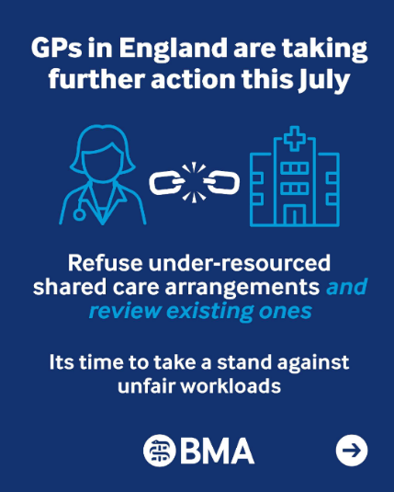
We are asking practices to refuse all new requests for shared care where these are not appropriately resourced. GPs and Practices should not accept new informal arrangements and should only enter them where terms are clear, clinically safe, and adequately resourced.

We also encourage practices to work with their LMCs and use this as an opportunity to review any existing arrangements, check that protocols remain up to date, clarify responsibilities, identify prescribing that takes place without formal agreements, and ensure that prescribing, monitoring and recall systems are robust and consistent.

Taking part in this action is lawful. Shared care arrangements are voluntary. GPs must only enter into them when they can provide care safely, have adequate resources, and have clear agreements in place that clearly set out responsibilities for everyone involved.

Without these safeguards, practices will likely struggle to deliver shared care safely while continuing to meet the wider needs of their registered patients.

Resources:

Action on shared care responsibilities for new patients in general practice
Template practice letter to MPs about the future of general practice
Principles for Shared Care Prescribing
Patient resources and practice campaign materials

Collective action: June onwards
During June, we asked practices to remove or ignore any non-contractual medicines optimisation software and amend the choices of acute prescription, which may fall outside the remit of the ICB formulary. This may include, for example, issuing a branded or liquid formulation that may still be a perfectly acceptable and justifiable choice for the care of the patient in front of you in the consultation. Read our Focus on guidance on Switching off medicines optimisation software

Collective Action: May onwards
Central to the ongoing collective action that began in May was practices sending a letter to their ICB:
asking them to assess each existing DSA your practice is currently signed up to while indicating you will stop agreeing to voluntary secondary uses data sharing agreements (DSAs).

Now send your follow-up letter. Thousands of practices have sent both, the two templates can be found on our resource page on Collective Action. If you’re yet to send yours - it’s not too late.

FP69 list cleansing update
Across England, practices are witnessing an unprecedented acceleration in patient list cleansing. What might appear to be a routine administrative exercise has rapidly become one of the most significant financial and operational challenges facing general practice this year. There is not only a financial impact on practices, but it may also be restricting patient access, especially for more vulnerable groups.

GPC England wrote to Minister Kinnock to raise our concerns, but have only received limited reassurances about the process. However, he has confirmed that funding released from this activity will be reinvested in general practice services and we are continuing to discuss with NHS England how this will be done. If your practice has seen a significant reduction in income from this process, please contact info.gpc@bma.org.uk with details.

The BMA media team are also looking for case studies and would like to hear from practices that have been adversely affected or from patients that have been erroneously removed. Please email Travis Yearwood tyearwood@bma.org.uk in our media team for further information.

UK LMC Conference news
The resolutions from the UK LMC Conference held in Belfast on 13-15 May have now been published.

Read more: Local medical committees
- The BMA’s GP campaign webpage
- The GPCE Collective Action page
- GPCE Safe Working Guidance Handbook
- Read more about the work of GPC England and practical guidance for GP practices
- See the latest update on X @BMA_GP and read about BMA in the media

GPCE bulletin: New GPC England officer team | neighbourhoods update | collective action

GPC England officer team

Email: info.lmcqueries@bma.org.uk (for LMC queries)
Email: info.gpc@bma.org.uk (for GPs and practices)

