Dear colleagues

Collective action against new GP contract - update
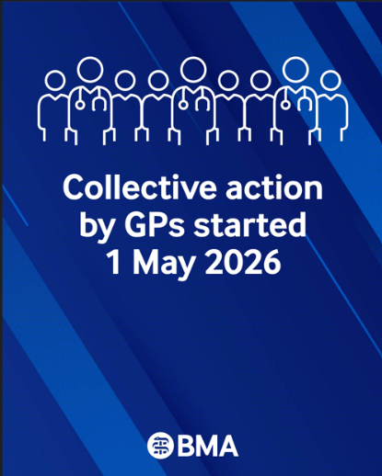
The GPs Committee for England (GPCE) met yesterday, 21 May, to discuss all the issues we currently face as well as the next steps of our collective action given the imposed contract we are working under since April 2026.

The next action, from 1 June is where we ask you to remove or ignore any non-contractual medicines optimisation software, and amend your choices of acute prescriptions which may fall outside the remit of the ICB formulary. E.g. Issuing a branded or liquid formulation may still be a perfectly acceptable and justifiable choice for the care of the patient in front of you in the consultation. This action would not go so far as to breach any regulations pertaining to you or your contract. We know some of you may have this software added onto your system as part of a locally commissioned service and we will issue more guidance in the first week of June, unless action can be averted by Government. Your LMC will also be able to advise further on this in due course. We are not asking you to take this action now, but will write to you again in June, if this planned escalation cannot be averted.

We are urging GP partners and practices to continue to take part in the current collective action, - see below for more information on this.

After Wes Streeting's resignation, we have written to the new Health Secretary, Rt Hon James Murray MP, to request an urgent meeting to resolve the current dispute arising from the imposed 2026/27 GP contract. Read the BMA statement in response.

An aspect of considerable concern is the new Health Bill going through Parliament which was announced in the recent King’s speech. The main issue before us is a proposed Single Patient Record (SPR) containing all of our GP notes. Our politicians seem to be seeking considerable oversight and control of this data from what we have seen in the initial documents published. Confidentiality of our patient’s data is of course fundamental to the patient- doctor relationship and any hint of politicians using this data for their own or commercial purposes will lead to a lack of patient trust. Any good intentions are obscured by the power grab and the complete lack of protections for patients. You may wish to read this briefing from MedConfidential

The committee has serious concerns about this Bill, and the BMA will be fully analysing the legislation and making our views known about the significant concerns we have.

GP collective action May 2026 – DSAs
We are urging GP partners and practices to take part in our current collective action, focusing on the flow of GP patient data outside practices, in the form of practice data sharing agreements (DSAs).

This action may reduce the liabilities on a partnership, and it will impact integrated care systems and the wider NHS Government agenda which is increasingly seeing a ‘left shift’ of work from hospitals into practices, without any commensurate resource to meet the challenge.

Action for practices:

Send the template letter to your local ICB, indicating you will stop agreeing to voluntary secondary uses data sharing agreements (DSAs) from May 2026. (The letter has been reviewed by the BMA legal team and an external leading KC Counsel – it is lawful, and it is not defamatory.)

- Refer any new DSA requests to BMA via gpcontract@bma.org.uk

- Carry out an audit of all existing DSAs that your practice is signed up to – see our guidance

- Initiate a conversation with your patient participation group (PPG).

We have prepared a range of resources to help practices understand the need to take part in this collective action: How to take part in GP collective action in England
Taking part in this action will both help your practice stay safe and put further pressure on the Government to build on the progress made and secure safeguards for practices to be able to deliver their GMS contract safely. The action is straightforward and does not breach your contract.

Access our guidance on our campaign page with the latest updates and guidance about the 26/27 contract changes and our dispute with Government, to help support you and your practices.

LMC UK Conference 2026 – ‘Everything needed urgent for today’
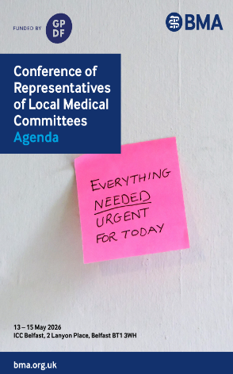
The LMC UK Conference was held last week in Belfast, Northern Ireland and brought together GPs from across the UK.

The Conference included debates on issues such as safe working limits to GP access, advice and guidance (A&G), harmful Google reviews of practices, and looking at a ‘Plan B’ that allow GPs to provide private services to their NHS patients.

In her speech, Dr Katie Bramall, Chair of GPC England, highlighted that:

‘Understanding precisely who has access to patient information, for what purpose, under what safeguards, and with what accountability. That is why the BMA England GP committee has initiated collective action around data sharing agreements.'

Watch the full speech by Dr Katie Bramall, chair of GPC UK and GPC England

The conference webcast and agenda are available >

The conference resolutions will be available on the BMA website shortly.

Rebuild General Practice petition
General practice is the front door to the NHS — but it is under increasing pressure. Patients are finding it harder to access care, and GPs are struggling to provide the continuity and quality of care they were trained to deliver.

Rebuild General Practice has launched a petition calling on government to restore capacity, protect continuity of care, and secure the future of the family doctor model. You can sign the petition here
NHS Workforce Plan

The Financial Times has received a leaked draft of the government’s new workforce plan, which was due to be released imminently – although the status of the plan is now unclear following the Secretary of State’s resignation. It reports that the government’s plan centres around increasing healthcare productivity – including through the use of AI and neighbourhood-based care – to cope with the hundreds of thousands of fewer staff than was envisaged under the previous workforce plan.

New measures would downgrade annual staffing increases to 1.1 - 2 %, suggesting that up to 380,000 fewer people will be working in the NHS in the mid-2030s than previously forecast. To support the government’s intention to move care closer to home, the plan says that up to 49,000 more GPs will be needed by 2035.

The BMA has issued a press release warning against placing a dangerous emphasis on AI at the expense of adequate workforce growth.

GP Registrars and trainers demand action on FourteenFish

The GP registrars committee (GPRC) remain concerned about the ongoing issues with the FourteenFish ePortfolio platform, including the withdrawal of the Consult function and wider operational problems following changes introduced by Optum.

Over recent months, GP registrars, trainers and TPDs have experienced the negative impact these changes are having on training, WPBAs, consultation recording, SCA preparation and progression towards ARCP. Therefore, GPRC have launched a petition for GP registrars and trainers, that calls for:

- urgent mitigations to address the impact of ongoing platform issues;
- express serious concerns about Optum’s ability to provide a reliable and sustainable service that meets the needs of GP registrars and trainers;
- call on the RCGP to engage with registrars on the long-term future of the ePortfolio platform, including consideration of alternative provision models.

We’d encourage all GP registrars and trainers who are concerned, to sign the petition.

Cameron Fund – the GPs’ own charity
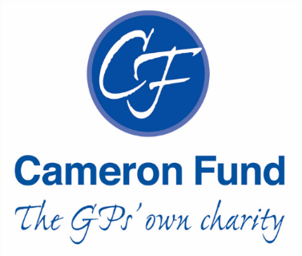
The Cameron Fund is the GPs’ own charity, the only medical charity which solely supports GP and their families in times of financial need, whether through ill-health, disability, bereavement, relationship breakdown or loss of employment.

To be eligible for assistance applicants must have worked as an NHS GP for at least one year, and ST3 GP Registrars can apply for interest-free loans for exams. The help is usually a monthly grant towards essential family living expenses, and by referring applicants to a Money Adviser who advises on benefits, debts and budgeting.

Over recent years there has been increase in GPs needing help, whilst the Cameron Fun income has struggled to keep pace. Half the income comes from the original investment fund, and it relies on donations from LMCs and individual GPs for the rest.

Find out how you can apply for help, or how you can help by donating: www.cameronfund.org.uk

Changes to Universal Credit payments

On 6 April 2026 the Department for Work and Pensions (DWP) made changes to Universal Credit payments, meaning that patients who are assessed to meet the Severe Conditions Criteria will receive the highest benefit entitlement. These criteria will be used to identify those with the most severe, lifelong health conditions or disabilities, who are unlikely to improve, and those who are not expected to ever be able to work.

When making a claim, if they think they meet the Severe Conditions Criteria, patients will be asked to send DWP any supporting medical evidence they already have.

DWP does not expect GPs and their teams to do any additional work for this new Criteria. In the event that a patient requests evidence from a GP team to support their claim, please advise them that the DWP, if they need it, will request any further information they require from the patient directly in the standard way. There is no need to provide any additional evidence directly to patients.

How to get the most out of the LMC Support Network

- Join the LMCSN WhatsApp group - an opportunity to share questions/thoughts/peer support.
- Use the web forum for discussions
- Share service level agreements for locally commissioned services
- Share any documents/templates/posters/videos so that they can be hosted on the website
- Come to virtual monthly LMCSN meetings

To share materials or ideas/comments etc, please email admin@lmcsn.co.uk or visit www.lmcsn.co.uk
- The BMA’s GP campaign webpage
- GPCE Safe Working Guidance Handbook
- Read more about the work of GPC England and practical guidance for GP practices
- See the latest update on X @BMA_GP and read about BMA in the media

GPCE bulletin: Collective action update | LMC UK conference | NHS workforce plan

Dr David Wrigley
GPC England deputy chair

Email: dwrigley@bma.org.uk
Email: info.lmcqueries@bma.org.uk (for LMC queries)
Email: info.gpc@bma.org.uk (for GPs and practices)

