
Dear colleagues

GP contract imposition and referendum
GPC England met on 26 February and voted to reject the Government’s 2026/27 GMS contract and to open a contract referendum of the profession on the imposed contract changes, which were announced on Tuesday last week.

It is vital you vote in the referendum. To do so, you must be a BMA member.

GP and GP registrar members should have received an email from Civica, inviting you to vote. You’ll be asked if you accept the Government’s changes to GP contracts for 2026/27, and its approach to making them, or if you want the Government to return to direct, meaningful negotiations with GPCE to jointly develop a new national GMS contract to restore the viability of partnerships, provide fair remuneration for all GPs, and implement workload safeguards to keep GPs and patients safe.

If you have not received an email from Civica with your voting link, please check your junk folders and contact GPContract@bma.org.uk if you don't have one.

The referendum opened on 4 March and is open until 12pm, Wednesday 25 March. Have your say on the Government’s changes to your practice contract for 2026/27.

The last day to join the BMA in order to vote in the referendum is 19 March – join the BMA.

No more empty words. No more broken promises. It’s time for action.

Listen to the GPonline podcast where the GPC England Chair, Dr Katie Bramall, talks about the imposed 2026/27 GP contract and the referendum >

Find out more on our website: www.bma.org.uk/GPcontract

Contract webinars
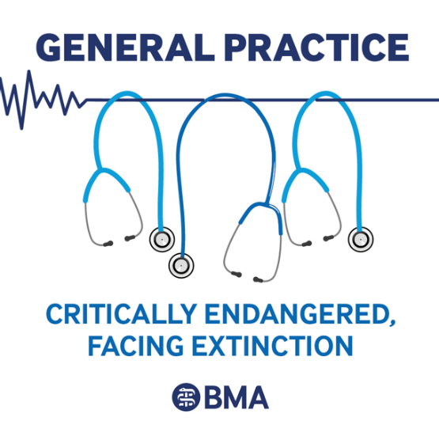
General practice is critically endangered, facing extinction and the Government must work with us to bring general practice back from the brink; this contract will not do that.

We are undertaking further webinars where we will discuss the new contract and what the next steps are for the profession. You can use the links below for these.

- Tuesday 10 March, 7-8:30pm – register here
- Wednesday 18 March, 12-1:30pm – register here

Please feed in any queries you have to info.gpc@bma.org.uk

‬Letter to GPs in England about fees for safeguarding work
The BMA’s Professional Fees Committee (PFC) has written to GPs in England about safeguarding work and the fees that applies for this work.

There are no agreed fees for completing safeguarding reports or attending case conferences. Following advice from King’s Counsel, the PFC’s position in relation to fees for safeguarding services, is that GPs are entitled to ask for a fee for safeguarding services as this work falls outside the scope of their GMS, PMS and APMS contract of employment. Read more >

Annual flu letter
NHS England have now published the annual flu letter, outlining the cohort and vaccine information for the 2026/27 flu programme. The letter can be accessed on the NHS England website

GPC England regional representative elections
- Hillingdon/Brent & Harrow/Ealing, Hammersmith & Hounslow
- Lewisham, Southwark & Lambeth/Bexley & Greenwich/Bromley
- Cheshire/Mid Mersey
- Northumberland/Newcastle & N Tyneside/Gateshead & S Tyneside/Sunderland
- Gloucestershire/Avon
- Wiltshire/Dorset
- Buckinghamshire/Oxfordshire
- Berkshire/ North & East Hampshire
- Barnsley/Doncaster/Rotherham/Sheffield
- Leicestershire & Rutland/Northamptonshire
- North Yorkshire/Bradford
- North Staffordshire/South Staffordshire/Shropshire
- Sandwell/Walsall/Wolverhampton/Dudley

The term for these roles will run from the conclusion of the ARM in July 2026 until July 2029. Due to changes in BMA rules some longstanding committee members may not be eligible to run or only be eligible to hold the role for one or two sessions. To stand for election you must be a member of the BMA, and work in the constituency for which you are standing.

Nominations will close at noon Friday 13 March 2026 – go to elections.bma.org.uk

If you have any questions or require assistance, please contact elections@bma.org.uk.

RCGP and Patient Association joint report

On Tuesday 24 February, the Royal College of General Practitioners and the Patients Association launched their joint report, "It shouldn't be this hard": Solving the NHS maze for patients and GPs. The report makes three recommendations to policy makers, based on engagement with patients and GPs on their experiences with navigating primary care. The recommendations are:

1. Every patient should find the NHS easy to navigate
2. Every patient should be able to see their GP when they need to
3. Every patient should be able to access their information and track referrals via user-friendly systems

Mental health consultation

The Department of Health and Social Care has launched an Independent review into mental health conditions, ADHD and autism: terms of reference. This review was promised by the Secretary of State, Wes Streeting MP, and we would recommend as many GPs as possible to contribute their thoughts and experience.

The mailbox to receive submissions is independentprevalencereview@dhsc.gov.uk

PCSE Online: New Access for GP Accountants

PCSE has introduced new permissions in PCSE Online that allow GP accountants to access Employee Contribution Statements and complete Type 1 and Type 2 certificates for GP Pension Scheme members.

Practice User Administrators can add or remove an accountant or authorised contact as needed. Each accountant must have a link to each Pension Scheme Member. The previous accountant role is no longer active, so new access must be set up in PCSE Online.

Further information can be found on the PCSE website.

Community pharmacy and general practice conference 21-22 June

The National Pharmacy Association (NPA) and Cogora is hosting the Community Pharmacy and General Practice Conference 21–22 June 2026 at the National Conference Centre in Birmingham.
The event will unite professionals from community pharmacy, general practice and wider primary care to redefine neighbourhood health.

The programme is created in collaboration with an Advisory Committee, including Dr Julius Parker, GPCE deputy chair. It features case-based sessions, built around five core streams: collaboration in action; business and service innovation; leadership and workforce; technology and AI for integration; clinical skills booster – delivering implementable ideas to strengthen integrated primary care. It is designed to share practical, case-based learning to help drive stronger collaboration between general practice and community pharmacy. Register free here.

How to get the most out of the LMC Support Network
- Join the LMCSN WhatsApp group - an opportunity to share questions/thoughts/peer support.
- Use the web forum for discussions
- Share service level agreements for locally commissioned services
- Share any documents/templates/posters/videos so that they can be hosted on the website
- Come to virtual monthly LMCSN meetings

To share materials or ideas/comments etc, please email admin@lmcsn.co.uk or visit www.lmcsn.co.uk

GP wellbeing resources
A range of wellbeing and support services are available to doctors, and we encourage anybody who is feeling under strain to seek support. Support comes in various forms, from the BMA’s 24/7 confidential counselling and peer support services and NHS practitioner health service to non-medical support services such as Samaritans. The organisation Doctors in Distress provides mental health support for health workers in the UK, and confidential peer support group sessions.

The Cameron Fund supports GPs and their families in times of financial need (through ill health, disability, bereavement, relationship breakdown or loss of employment). The RCGP also has information on GP wellbeing support. The BMA has produced a poster with 10 top tips to support wellbeing.

Visit the BMA’s wellbeing support services page or call 0330 123 1245 for the counselling line.

- The BMA’s GP campaign webpage

- GPCE Safe Working Guidance Handbook

- Read more about the work of GPC England and practical guidance for GP practices

- See the latest update on X @BMA_GP and read about BMA in the media

Read the GPCE bulletin:

GP contract referendum | upcoming contract webinars | fees for safeguarding work

Dr Julius Parker
GPC England deputy chair

Email: info.lmcqueries@bma.org.uk (for LMC queries)
Email: info.gpc@bma.org.uk (for GPs and practices)

