Dear colleagues

LMC England Conference 2025 update
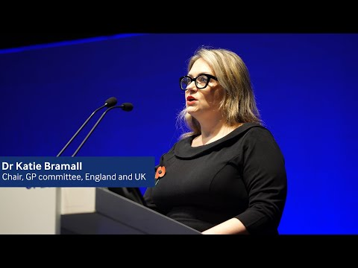
Watch a clip of my speech

The 2025 LMC England Conference took place last week in Manchester, where we debated our current dispute around not just the lack of any safeguards to mitigate patient harm with recent online access changes, but also the broken government promise over a new GMS contract, with motions calling for GPC England to prepare for mass non-compliance, onward balloting of the profession, and collation of undated resignations of practice contracts. The resolutions from the Conference will be published shortly. For more information about the LMC Conference see here:
Local medical committees.

In my conference address, I expressed my own and the wider profession’s frustration and profound disappointment in this government. Back in March there appeared to be goodwill, good faith, and a promising future. But, instead of working with us to implement what was needed to keep patients and practices safe, we face broken promises, squandered opportunities, and a disregard of our consistent patient safety concerns.

Then came July, and the Ten Year Health Plan – no mention of Mr Streeting’s written commitment to renew GMS but instead describing brand-new single and multi- neighbourhood provider contracts: unevidenced, unfunded, uncosted, unprotected, and unknown.

Clearly, the truth hurts. We have subsequently seen government and our detractors not just brief against us in the press, but following Conference, Mr Streeting has instructed NHSE and DHSC to cancel all current meetings with GPCE. We will be holding an extended series of webinars starting next month, sharing with the profession exactly what was agreed, and when, as well as teasing out what comes next.

Next week, as we discuss below, we will be releasing the findings of our online consult practice survey. Over a thousand practices completed this, that’s more than 1 in 5 across the country – a significant number, which is immensely helpful – thank you. Government may not like what we tell them, but we will continue to act in good faith and with a cool responsible head to do what is in the best interests of our patients, our practices and the profession.

We stand together - united as a profession on the brink: practices feeling unsafe; GPs under-employed; partners exhausted, sessional GPs frustrated. As your GPC England officers, we stand ready: to get back round the negotiating table and to stand ready to lead if the profession takes the decision to act. It is easy to feel the pressure, but the power to change everything is in our gift.

Watch a clip of my speech

Online consultation survey
Thank you to everyone who took the time to respond to our recent online consultation survey. More than one in five practices in England responded – over 1,300 unique and validated responses were recorded. Together, these practices represent nearly 14,000,000 patients – over 20% of England’s registered patient population.

The survey results will help us evaluate the impact of the October 1st regulations coming into effect, which mandate GP practices in England to keep online consultation platforms open during core hours. GPCE officers have been consistent with government since Wes Streeting set out his ambition last December – current online consult tools preclude the ability to safely discriminate between urgent and routine patient need. The current contractual expectations go beyond what was agreed in good faith at the start of the year. But irrespective of semantics and wordplay from government, patient safety is at risk now.

Initial findings indicate that the regulations are putting patients at risk, and safeguards are clearly required to prevent urgent requests filtering through as routine or admin requests. In addition, practices are reporting an increased, and unsustainable, volume of requests since October 1st; with a changing attitude in patients reflecting a transactional, rather than holistic, style of medicine.

Our team is currently crunching the numbers and analysing the many free-text responses, and we will be ready to share results shortly.

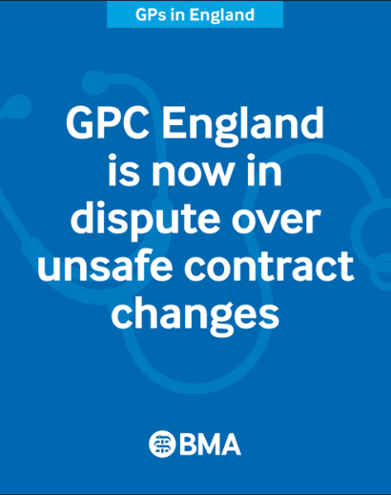
GPC England dispute over contract changes
We remain in dispute with the government, however this does not mean practices can ignore the contractual changes that were implemented on 1 October 2025, nor can GPC England or LMCs recommend or endorse such an approach. Declaring a dispute is akin to declaring compliance with the new contractual requirements in the 25/26 contract agreement in March 2025, but “under protest”. Therefore, practices must:

- have an online consultation tool, which is available to registered patients throughout core hours (8am – 6.30pm), to allow them to make non urgent / routine appointments requests, medication queries and administrative requests and
- ensure GP Connect (Update Record) write access functionality is enabled.

Whilst many practices are struggling, we would remind you that support and guidance for practices in relation to the contract changes is available here: Campaigning around GP contracts in England.

As we prepare for further escalatory options, please encourage any GPs or GP registrars who are not BMA members to join so that they may vote in any potential future ballot, and ensure your own membership information is up to date.

Following the LMC England Conference, GPC England is now considering all our options and what our next steps should be. The safety of our patients and working in the best interests of you and your team is our first concern.

Access all the guidance: Campaigning around GP contracts in England

Resident doctors' and GP registrars’ strike action guidance
Resident doctors (including GP trainees) are taking industrial action from tomorrow, 14 November, after 90% voted in favour of to strike over pay erosion and insufficient specialty training places, after the Government has failed to present a credible offer to restore their pay or fix the specialty training crisis in England.

GP Registrars have the full support of GPC England, general practice and the wider profession during the strike action.

Ahead of the strikes we published guidance for practices, LMCs and GP trainers, advising on how practices can support their GP registrars and manage strike days. Read the guidance
Read also the guidance on striking as a GP Registrar.

NHS reforms - Neighbourhood health service
At the NHS Providers Conference yesterday, the Secretary of State for Health, Wes Streeting, announced plans to deliver the next phase of integration of NHS England with savings to be reinvested in ‘frontline care’. The reforms will give more power and autonomy to local leaders and systems to reduce red tape and bureaucracy, so they have more freedom to better deliver health services for their local communities. What this means for general practice and its commissioning is far from certain.

The Government has committed to reducing the running costs of Integrated Care Boards (ICB), with a more clear and focused purpose as strategic commissioners than previously. ICBs will be tasked with transforming the NHS into a neighbourhood health service, with a greater focus on preventing illness. This will mean ICBs will be leaner organisations, with half their current posts removed.

If the government plans are to have any hope of success, they will need GPs around the table leading local discussions. How general practice engages with these reforms, and what we collectively decide could make or break the current ambitions of the Ten Year Plan. The government’s key three aspirations are largely already delivered by our profession: analogue to digital (we have been paperless for years); sickness to prevention (we actively want to push prevention rather than react to political ‘access’ targets) and hospital to community – but we see precious little evidence of this happening. It is clear that general practice is the clear solution to so many of the government’s current challenges, they need to start moving away from labelling us as the problem.

Read more: Billions to be redirected back into patient care with NHS reform - GOV.UK

GP wellbeing resources
A range of wellbeing and support services are available to doctors, and we encourage anybody who is feeling under strain to seek support, such as the BMA’s counselling and peer support services, NHS practitioner health service and non-medical support services such as Samaritans. The organisation Doctors in Distress also provides mental health support for health workers in the UK. We have produced a poster with 10 top tips to help support the wellbeing of you and your colleagues.

The Cameron Fund supports GPs and their families in times of financial need and the RCGP also has information on GP wellbeing support.

Visit the BMA’s wellbeing support services page or call 0330 123 1245 for wellbeing support.

- The BMA’s GP campaign webpage
- GPCE Safe Working Guidance Handbook
- Read more about the work of GPC England and practical guidance for GP practices
- See the latest update on X @BMA_GP and read about BMA in the media

GPCE bulletin: LMC conference update I GPC England in dispute | residents' strike action guidance

Dr Katie Bramall
GPC England chair

Email: info.lmcqueries@bma.org.uk (for LMC queries)
Email: info.gpc@bma.org.uk (for GPs and practices)

