Dear colleagues

GPC England votes to enter dispute from 1 October
At the GPC England meeting yesterday, the committee voted to go back into dispute with the Government, DHSC and NHS England from 1 October​ 2025 on the grounds of patient safety, workforce wellbeing, and GP risk.

When GPC England voted to accept the 2025/26 contract back in March, we mutually agreed with Government, DHSC, and NHS England that necessary safeguards must be in place in time for the start of October’s contract changes. For GP Connect Update Record (write access) the JGPITC have tried to work with NHS England counterparts to make the tool safe, but as communicated in their statement, it is not yet safe.

We have similarly tried to work with NHS England and DHSC colleagues to explore changes to the online consultation platforms to provide additional functionality for routine appointment requests. The simplest and safest way to do this would be via tick box questionnaire setting, akin to the Florey questionnaires we wrote and uploaded in the early months of the Covid19 Pandemic. By eliminating the option for free text with such a functionality, you eliminate potentially urgent problems erroneously slipping through – creating risk for patients and their GPs alike. This would also allow the current free text option to be switched off once the practice capacity is reached, knowing that the routine functionality would be kept on.

Despite our best efforts over the past six months, our concerns are being ignored and there is presently a refusal to ensure any of the necessary safeguards we committed to are in place to protect patients and practice staff from harm. This situation has been made worse by the 10 Year Health Plan’s recommendations to proceed with novel GP contract structures, which risk diminishing GMS and undermining the Secretary of State’s written commitments of 19 March and 11 August.

We are considering all our options, including potential legal action, to ensure the most harmful aspects of this Government policy are challenged and reversed. Of course, the Government could avoid all this entirely, by simply providing the safeguards and the clarity that we need which would not cost them a single penny

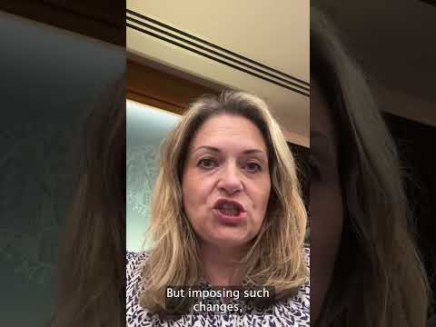
Should Government double down, we will have no option but to ballot contractors across the country as to the potential next steps. It would be in patients and practices’ best interests for NHS England and DHSC to work with GPC England to agree the functionality required to deliver what the Secretary of State has asked for safely.

Read more here

Watch my 2 minute video summary here and >

Read our press statement.

October 1st contract changes - essential guides
GPC England has prepared guidance to assist preparations for the changes to the GP practice contract from 1 October, and will be producing more in the coming days:

Guidance explaining the regulatory changes for 2025/26

GPC England has published guidance to explain the regulatory changes for 2025/26 and considers what these mean for your practice and the patient contact clauses which were imposed in 2023/24. We also set out advice for exactly how to remain compliant in relation to the three modes of access, i.e. walk-in attendance at the practice, contact via telephone, and contact via online consultation.

Guidance providing practical advice on how to manage patient care safely post-1 October

The following guidance provides practical advice on how to manage patient care safely from 1 October. It contains advice on reviewing your practice’s workflow and triaging arrangements; considerations regarding the introduction of waiting lists for routine care; and reminders of how to revisit and use our BMA safe working guidance handbook.

Our contract guidance will be updated, to answer further queries from members.

Joint GP IT Committee position statement on GP Connect: Update Record

In addition, the Joint GP IT Committee has published a statement on the current state of GP Connect: Update Record following their meeting on 3 September, which has been shared with NHS England in light of plans to make this functionality a requirement.

Read more about the contract changes and access our guidance on our campaign page: GPs in England: staying safe, organised and united.

Special Representatives Meeting - 10 Year Health Plan and impact on general practice
The BMA has held a Special Representative Meeting (SRM) to debate the risk of the NHS England 10-Year Health Plan. The Secretary of State for Health and Social Care, Wes Streeting, answered questions on how the NHS 10-year plan aims to tackle the doctor unemployment crisis across the health service.

Watch the whole address by the Secretary of State: https://youtu.be/C3q5vcVqKjk

There was a dedicated section on the implications for general practice, and motions confirming our already stated concerns on the Plan, such as:

- The threat to independent contractor status of GPs
- Trusts being inappropriate organisations to absorb the commissioning or operational responsibilities for general practice
- The GMS contract requirement from 1 October 2025 to keep on-line non-urgent (routine) appointment request functionality open from 08.00 until 18.30 Monday-Friday is not safe
- Integrated Health Organisations (IHOs) pose an existential threat to the GMS contract and demanding that the BMA campaign against the move to form IHOs
- For the BMA to campaign against the use NHS of private providers and private investment

There was also a motion passed expressing that “The Plan poses an existential threat to the GP independent contractor model, the GMS contract, and therefore the very concept of the family doctor” and that it “condemns and opposes the 10 Year Plan as it is currently written”.

GPCE has previously raised concerns with the plan and the potential negative consequences on practices and their patients, especially the risks posed by its proposals on greater integration and the potential for GP services to be vertically taken over by hospitals and other large providers.

Read more about the SRM, including a full list of resolutions.

Read the BMA’s comprehensive analysis of the 10 Year Health Plan.

Ministerial briefing about the 10 Year Plan
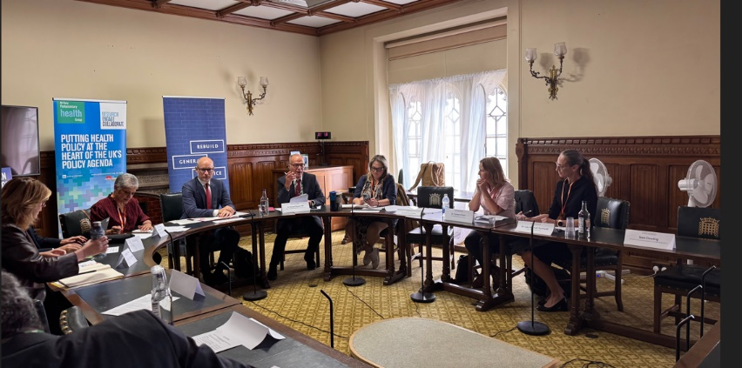
Last week, the Rebuild General Practice campaign and the BMA convened a high-level Ministerial briefing in Parliament to discuss the 10 Year Plan, chaired by Dr Simon Opher MP and attended by Department of Health and Social Care Minister, Stephen Kinnock MP.
GPs from across the country including GPC England’s chair Dr Katie Bramall, deputy chair Dr Samira Anane and Londonwide LMCs’ chief executive Dr Lisa Harrod-Rothwell joined MPs, House of Lord members and parliamentary leaders to respond to the Government’s 10-Year Health Plan, raising urgent concerns around protecting GMS, the emerging neighbourhood structures, parity of voice for primary care at the system table digital exclusion, and the future of GP surgeries.

The meeting identified two priority areas that the government should take forwards as they look to develop and implement the plan:

- Flexibility for Single Neighbourhood Contracts to be held alongside GMS contracts.
- Strengthening the GP Voice at the Board Table across new ICB clusters

The message from the frontline was clear: GPs are essential to the success of neighbourhood care, but without meaningful investment or change, the system cannot deliver for patients.

OpenSAFELY data provision notice
Practices using EMIS Web (Optum) and SystmOne (TPP) should continue to accept the DPN (data provision notice) for OpenSAFELY to allow expansion to non-COVID-19 analyses now that it has been sent.

OpenSAFELY has the full support of GPC England and the Joint GP IT Committee and, as NHS England becomes the data controller of the outputs of queried data, any data protection risks are held by NHS England. It is a legal requirement for practices to accept the DPN. Data will only be made available under the legal direction once the practice has signalled approval.

New GOV.UK Pay arrangements coming soon for locum pension payments
From 1st October 2025 it will be possible for locum GPs using PCSE's online portal to submit their Locum B forms and pay their employer and employee pension contributions to use the GOV.UK Pay service, rather than sending money via BACS and then updating the 'recording income stream' section on the portal. This should reduce the work for locum GPs and will also allow a more rapid updating of the records held by PCSE as the payment will instantly be tied to the Locum B submission. PCSE are running a webinar at 6pm next Wednesday (24 September 2025) on this. To enrol click here

National Neighbourhood Health Implementation Programme (NNHIP) survey
The Government has now rolled out the first neighbourhood health services in 43 places across England. We want to hear from you about your awareness and engagement with the NNHIP first wave of applications to join the programme that were invited in July.

We plan to use this insight to lobby for changes to the process and to help support our members who will be involved in the programme, as well as those who may take it up subsequently. It’s important therefore that we hear from both respondents who have been leading the process in their locality, but also from those who have been engaged to a lesser extent or are indeed unaware of the programme. GPC England members challenged the national medical director at last week’s Parliamentary briefing with the Minister over the importance of practice and PCN CD consent and co-production in programme design and delivery. Take part here

We are asking for people to share copies of their NNHIP plans by sending them to info.gpc@bma.org.uk, and we hope to share learning from the survey and applications to help support GPs and practices moving forward.

BMA GP pensions newsletter

We encourage you to take a look at the recent GP pensions newsletter circulated by the BMA’s Pensions Committee, if you haven’t already done so. This includes a recent win in terms of now being able to log GP appraisal work for up to 3 days and a link to NHS England’s compensation factsheet for complaints relating to PCSE’s pension administration.

Representation of GP Educators working for NHS England
We are aware that a number of GPs that work for NHS England as educators, training programme directors and associate deans are concerned about what the future might bring with the proposed abolition of NHS England. The Medical Academic Staff Committee has reached out to the NHS England Local Negotiating Committee and the Chair has offered to meet with those affected and update them on developments to the extent that he is aware. If you would be interested in taking part in that meeting and being contacted by MASC and the LNC about the issues please e-mail info.masc@bma.org.uk with your details.

Doctors to be allowed to prescribe flu medicines all year-round
The government has announced it will allow doctors and pharmacists to prescribe flu medicines year-round to reduce winter pressures and protect the NHS. Read more

England LMC conference 2025 – deadline to register
The England LMC conference will be held on 7 November at the Royal Northern College of Music, Manchester.
The deadline to register is noon, Wednesday 1 October 2025 - LMCs are asked to ensure that their LMC representatives and observers are registered correctly via this link. It is the LMC's responsibility to ensure that their representatives and observers are registered before the deadline.
If you have any queries regarding this conference, please email info.lmcconference@bma.org.uk

GP wellbeing resources
A range of wellbeing and support services are available to doctors, and we encourage anybody who is feeling under strain to seek support, such as the BMA’s counselling and peer support services, NHS practitioner health service and non-medical support services such as Samaritans. The organisation Doctors in Distress also provides mental health support for health workers in the UK. We have produced a poster with 10 top tips to help support the wellbeing of you and your colleagues.

The Cameron Fund supports GPs and their families in times of financial need and the RCGP also has information on GP wellbeing support.

Visit the BMA’s wellbeing support services page or call 0330 123 1245 for wellbeing support.

- The BMA’s GP campaign ‘staying safe, organised and united’ webpage
- GPCE Safe Working Guidance Handbook
- Read more about the work of GPC England and practical guidance for GP practices
- See the latest update on X @BMA_GP and read about BMA in the media

Read the GPCE bulletin:
GPC England votes to enter dispute I October contract changes | 10-year health plan

Read the Sessional GPs newsletter: Meet our new co-chairs | DDRB resources | GP support hub

Dr Katie Bramall
GPC England chair

Email: info.lmcqueries@bma.org.uk (for LMC queries)
Email: info.gpc@bma.org.uk (for GPs and practices)

