Model Integrated Care Board (ICB) – Blueprint v1.0. - A Summary for LMCs
The Model Integrated Care Board (ICB) – Blueprint v1.0 outlines a transformative redesign of Integrated Care Boards (ICBs) to align with the NHS 10-Year Health Plan. It provides a strategic framework for the future role, functions, and structure of ICBs in England. This summary document is provided for LMCs to use in discussion with GPs.
Introduction
The Blueprint was written by a group of ICB leaders in partnership with NHS England on the basis that delivery of the 10 Year Health Plan will require a leaner way of working, where every part of the NHS is clear on its purpose, what it is accountable for, and to whom. It was developed without a clear picture of what the future of neighbourhood health will look like or the role of the centre or regional teams. The 10 Year Plan is expected to set out more detail on the wider system architecture. ICBs will have a role to play as strategic commissioners working to improve population health, reduce inequalities and improve access to more consistently high-quality care.
Context
- Integrated care Boards (ICBs), established in July 2022, are the statutory NHS bodies tasked with planning, commissioning, and overseeing health services in their local areas.
- ICB delivery functions currently include emergency planning, safeguarding, NHS Continuing Healthcare assessment and provision.
- The Darzi review noted that “there have been differing interpretations of the role of ICBs resulting in increasing resources directed to acute providers, when the four objectives should have instead led to the opposite outcome.” The review advocated for a rebuilding of strategic commissioning capabilities, requiring “as strong a focus on strategy as much as performance” and a parallel investment in the skills required to “commission care wisely as much as to provide it well”.
- The Secretary of State has committed to focusing on three shifts which form the basis of the model ICB’s approach to redesign namely Treatment to Prevention
(with an emphasis on preventative health and wellbeing, proactive community and public health initiatives and reducing health inequalities), Hospital to Community (moving care closer to home, reducing reliance on secondary care) and Analogue to Digital ( harnessing data, analytics -population health management, predictive modelling, and digital tools for more efficient and personalised care delivery).
Purpose and Role of ICBs
ICBs exist to:
- Improve their population’s health by providing system leadership in setting the long-term population health strategy.
- Ensure access to equitable, high-quality care in line with best practice.
- Act as strategic commissioners and healthcare payers to deliver the strategy, aligning resources with long-term health outcomes.
- Manage risk, both clinical and financial, while co-producing strategy with communities and partners.
The refreshed role of ICBs has been developed through a set of assumptions about a new system landscape as below:

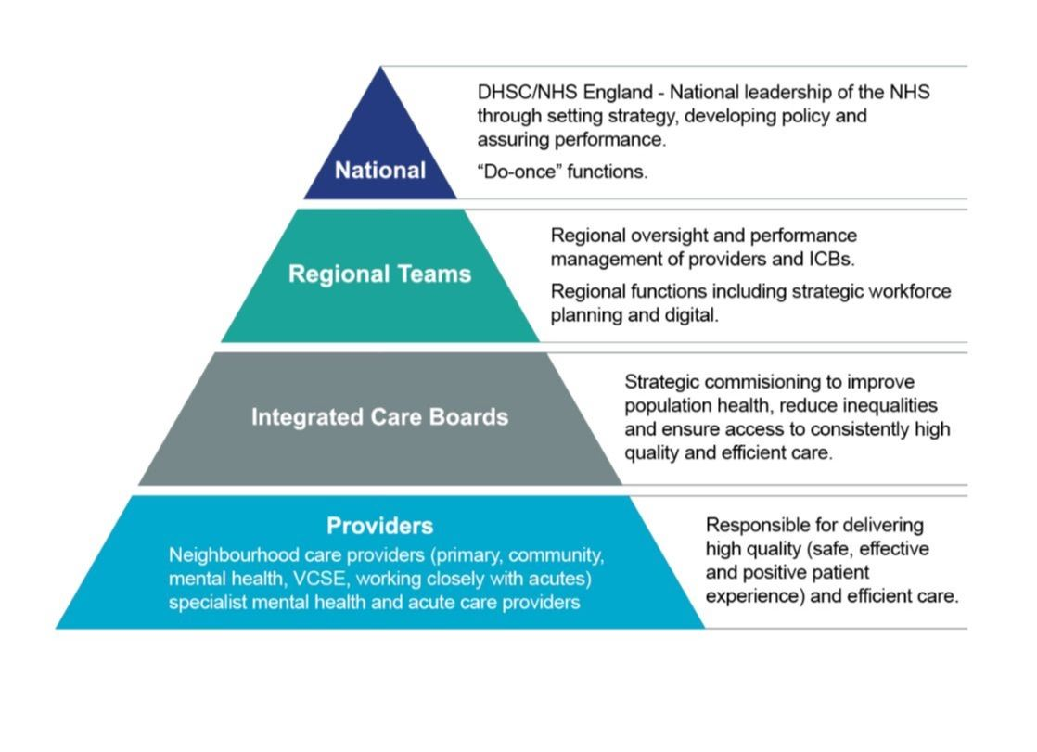
Model ICB Core Functions and Activities
ICBs will now focus on four core functions:
1.Understand Local Context
- Use data and insights to assess population health needs now and in the future. Identify inequalities using real time data. Stratify health risks. Assess the effectiveness of existing provision. Understand current and future costs.
2. Develop Long-Term Population Strategy
- Design and test population health strategies with stakeholders. Work closely with clinical leaders.
- Draw on a variety of inputs (e.g. user priorities, data analysis, evidence base on what works, horizon scanning, bottom-up costing, impact analysis).
- Align funding with population needs and best-value interventions based on evidence.
3. Deliver the Strategy through Payer Functions and Resource Allocation
- Strategic commissioning of services, shaping the provider market.
- Align funding to needs using data-driven models.
- Prioritise interventions to address health inequalities.
- Design outcome-linked contracts, innovative payment models (including designing incentives such as blended payments, gainshare, shared savings), and manage resource allocation.
- Monitor provider performance. Benchmark services with continuous review of impact, access and quality.
4. Evaluate Impact
- Monitor care utilisation (use real-time dashboards for day-to-day oversight of service usage), outcomes, and user feedback.
- Identify unwarranted variation. Embed continuous learning and adaptive planning.
Additionally, ICBs must meet governance and core statutory functions to be compliant, accountable and safe.

Functional Evolution of ICBs
ICBs are asked to consider the functional changes that may be required to support the proposed new model. No timeframes are given. ICBs must work closely with partners nationally and in local systems over the coming months to identify next steps.
Grow/ Invest
Functions to enhance:
- Population health management – data and analytics, predictive modelling, risk stratification.
- Strategic planning (including pathway redesign), commissioning, purchasing and partnerships (public health, VCSE, academia, local partners).
- Health inequalities expertise using data to generate actionable insights and support resource allocation and commissioning decisions.
- Commissioning neighbourhood health and end-to-end pathways (including those delegated to ICBs by NHSE such as ophthalmic, dental, pharmacy, general practice services). Vaccinations and screening will be delegated by NHS England to ICBs in April 2026. All remaining NHS England direct commissioning functions will be reviewed during 2025/26.
- Core payer functions.
- Evaluation methodologies.

Retain and Adapt
Functions to streamline or consolidate:
- Quality assurance – understand drivers of improved health, safety, effectiveness, user experience. Build into contracts.
- Clinical governance (management of population clinical risk, best practice care pathways).
- Board governance – streamline Boards.
- Corporate governance and operations (HR, finance. Audit, PALS). Deliver some functions at scale.
- Existing local commissioning functions including clinical policy and effectiveness and local funding decisions.

Review for Transfer
Functions likely to move over time from ICBs to:
- National: Data collection, management and processing.
- Regions: Performance management, regulatory oversight, strategic workforce planning, research development and innovation, emergency preparedness resilience and response (EPRR).
- All Providers: Local workforce development and training including recruitment and retention, operational delivery, green plan and sustainability, digital and technology leadership (enabled by a national data and digital infrastructure), estates, medicines optimisation, pathway and service development programmes.
- Neighbourhood health providers: Development of place-based partnerships, primary care operations and transformation (including primary care, medicines management, estates and workforce support).
- Options to move functions will be tested and explored for infection prevention and control, NHS continuing healthcare, general practice IT, safeguarding and SEND. Safeguarding and SEND would require legislative changes.

Enablers and Capabilities
To ensure success, ICBs will require:
- Healthcare data and analytics infrastructure
ICBs will need to:
- develop strong population health management approaches and robust data capability.
- segment the population to stratify risk and build a person-level, longitudinal, linked dataset integrating local and national data sources alongside public and patient feedback.
- deploy predictive modelling to foresee future demand, cost and impact of interventions.
- cultivate teams with the ability to analyse and interpret complex data
- use the NHS Federated Data Platform (FDP) as the default tool. Use integrated data between services to provide real-time, accurate data enabling better decision-making and interoperability.

- Strategy capability in value-based healthcare and partnership working. Strategic leaders who can diplomatically and collaboratively work with a range of partners. Individuals with problem solving and analytical skills.
- Advanced payer capabilities including procurement and cost modelling and use of contracting levers to incentivise quality improvement and innovation
- User involvement and co-design. ICB should meaningfully involving patients, service users, carers, and community groups in designing solutions. This goes beyond formal consultation and means working with people as partners.
- Clinical leadership and governance embedded in decision-making particularly regarding the prioritisation of resources.
- System leadership for population health. ICB leaders and staff who are adept at system thinking, analytics, and collaboration who work diplomatically and are comfortable driving change and influencing without direct authority.
- Strong local partnerships, especially with local government.
- A national support offer and maturity assessment to support ICB competency and capability building, including development of a new commissioning framework.

Managing the Transition
Cost Reduction
- ICBs must operate within a new budget envelope of £18.76 per head by Q3 2025/26. ICB plans setting out how this will be achieved to be submitted to region by 30 May 2025.
- Identify efficiency opportunities: At scale working with greater collaboration, clustering, and potential ICB mergers (coordinated by regional teams), benchmarking, AI and technology use.
- Generating savings cannot be a cost shift to a provider unless overall there is the saving. E.g. A provider takes on an ICB operated service and therefore requires circa 50% less cost in line with the £18.76 running cost envelop.
Impact on Staff
- A “National support offer “to ensure fair treatment of staff affected by the transition - redundancy schemes, redeployment, and clear communication.
- Partnership with trade unions to manage workforce change.
Leadership and Governance
- Streamlined boards, with emphasis on strategic, financial, contracting and clinical leadership and skills in population health data and insights.
- Creation of Transition Committees with responsibility for managing local risks, tracking progress, and overseeing the development of organisational design and implementation.
Function Transfers
- Require readiness assessments and governance frameworks.
- NHS England will lead coordination (and check and challenge ICB plans), supported by FAQs and planning templates.
- NHS England is developing the operating model for the Model Region. Performance management of providers will transfer to regions. ICBs will oversee providers through their contracting arrangements but will not be responsible for leading the regulatory oversight of providers.

END OF SUMMARY
The following section outlines some key take away points for General Practitioners to consider:
1. Shift in Commissioning Responsibility
- Primary care services, including General Practice, are currently commissioned by NHS England but are in the process of being delegated to ICBs.
- Over time, commissioning responsibility for primary care operations and transformation will be transferred further to neighbourhood health providers, shifting the design and operational delivery of primary care into the community.
Implication for GPs:
- GPs will increasingly engage with local neighbourhood teams rather than ICBs for support, transformation initiatives, and operational issues.
- GPs may experience more place-based commissioning that is tailored to local population needs.
- There is likely to be a lead provider organisation – who could that be in your area?

2. Integration into Neighbourhood Health Teams
- The Model ICB supports a system where care is moved from hospitals into the community, with a stronger role for integrated neighbourhood teams, including GPs, community services, mental health, and voluntary sectors.
Implication for GPs:
- GPs will play a central role in delivering joined-up care at a neighbourhood level, becoming more integrated into multidisciplinary teams.
- They may take on expanded responsibilities in population health management, proactive case finding, and care coordination.

3. Operational Support Functions to Transfer Away from ICBs
ICB responsibilities that are currently relevant to GPs and are set to transfer to providers include:
- Primary care estates planning
- Workforce support and transformation
- Medicines optimisation
- GP IT support
Implication for GPs:
- While strategic commissioning oversight will remain with ICBs, delivery support functions (e.g., IT, workforce, premises) will eventually be managed by providers or regional systems.
- This may lead to providers having greater influence on the infrastructure and tools that GPs rely on.

4. Payment Models and Contracting
- ICBs will retain and enhance capabilities around contracting, market shaping, and outcome-based payment mechanisms.
- There will be an emphasis on blended payments, gainshare models, and incentives linked to reducing inequalities.
Implication for GPs:
- GP contracts may be increasingly tied to population health outcomes and performance metrics.
- There could be greater financial accountability and new incentive structures that reward equity, efficiency, and quality.

5. Expectations Around Engagement and Co-Design
- ICBs will embed user feedback and co-design in all planning processes.
- This includes engaging GPs and primary care teams in strategic decision-making and service redesign.
Implication for GPs:
- GPs will be expected to take part in collaborative planning, particularly in the development of new care models and neighbourhood services.
- They may also contribute more actively to strategic forums and evaluation efforts.

6. Emphasis on Digital and Data Integration
- GPs will be expected to contribute to and benefit from integrated data systems supported by the NHS Federated Data Platform (FDP).
- ICBs will use real-time dashboards, predictive analytics, and outcome tracking to guide care.
Implication for GPs:
- Increased data transparency and data-driven decision-making will influence care planning at the practice level.
- GPs may see a rise in reporting and analysis expectations but also improved insights into patient needs and system pressures.

Conclusion
The Model ICB Blueprint sets the stage for a more localised, integrated, and digitally enabled primary care system, with GPs at the centre of neighbourhood health delivery. However, the transition will require strong local collaboration, clear communication, and support for GPs to adapt to new commissioning structures and delivery models. Ensuring GPs are actively involved in the development of these changes will be critical to their success and sustainability.

