Dear colleagues
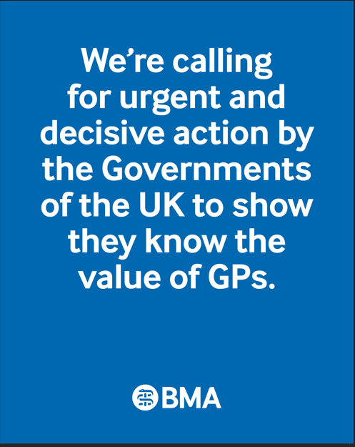
The Value of a GP report
As patient need continues to rise, general practice is buckling under immense pressure. GPs are leaving the profession, or reducing their NHS commitments, at an alarming rate, driven by burnout, unmanageable and often unsafe workloads, and the pull of more attractive careers abroad. And yet, despite this, many fully trained GPs remain unemployed or underemployed while communities struggle to access care. This is a tragedy both for those GPs, and for patients who could benefit were those GPs able to work

In response, at the UK LMC Conference last week, GPC UK launched The Value of a GP report that brings together a robust body of evidence to highlight the irreplaceable role of general practice in the UK. The report demonstrates the far-reaching impact of GPs, not only on the health and experience of individual patients but on the overall efficiency, sustainability, and economic value of the NHS itself.

General practice is at a pivotal moment. Without bold and immediate action to support and retain GPs, we risk the collapse of a service that underpins the entire NHS.

Watch the speech by Dr Katie Bramall at the UK LMC Conference about the report: https://youtu.be/RTePDQbpUhU

Read the report: BMA general practitioners committee UK overview

See also BMA GP X

LMC UK Conference 2025 - 'The GP unemployment paradox'
The LMC UK Conference was held last week at the SEC, Glasgow, Scotland.

The Conference, which had a theme of the ‘GP unemployment paradox’, included a themed debate on the unemployment crisis, and the Chair of the BMA Sessional GPs Committee, Dr Mark Steggles, shared “heartbreaking” stories from GPs who are struggling to find any or enough work in the NHS, as the unemployment crisis in general practice deepens.

In a speech by the co-Chairs of the BMA’s GP Registrars Committee, Dr Victoria McKay and Dr Cheska Ball called for “ring-fenced funding direct to practices to employ newly qualified GPs”.

At the Conference, representatives also gathered outside the Conference venue to call for urgent action to end the GP unemployment crisis https://x.com/BMA_GP/status/1920477955714674922

The Conference resolutions will be available on the BMA website shortly.

The agenda: 'The GP unemployment paradox' and further information is available >

Funding for GP surgery refurbishments
In response to the Government’s announcement of new funding for GP surgery refurbishments, Dr Katie Bramall, chair of GPC England, said:

"All new funding is welcome in the current parlous situation many GPs find themselves in, but the scale of the task facing the Government is far greater than these sums would suggest. To put it in context, £102m would barely pay for a handful of individual new surgeries, let alone do much to restore the more than 1000 it is aimed at.

Many of these surgeries are a constant headache for the GPs who work in them. GPs want to be focused on patient care and delivering a good service - not anxious about the decision to either keep staff or keep their surgery buildings in a fit condition.”

Read the full statement: BMA responds to new funding for GP surgery refurbishments

Read also a feature on GP practices working out of crowded spaces in the Doctor magazine

Patient Registrations for GP practices - PCSE
PCSE (Primary Care Support England) is hosting a webinar on patient registration for GP practices on Thursday 22 May, 1 – 2.30 pm. The webinar follows previous similar events, which have received very positive feedback, and will cover the following topics:

- Registering patients
- Avoiding rejected registrations
- Special Allocation Scheme (SAS)
- GMS3 Temporary Resident forms
- Managing confusions and duplicates
- Gender reassignments
- Nursing home flags (RI Codes)
- Managing GP Links and Interchanges

Register for the webinar: Webinar Registration: Patient Registrations for GP practices

There are also useful FAQs on patient registration and deregistration available on the PCSE website:

All Patient Registration FAQS
Patient Removals FAQs

In addition, please note the following update from PCSE in relation to patients removed from the GP’s list for reasons that warrant an immediate removal, which can only be requested when an incident involving the patient has been reported to the police by your practice. Such patients will be allocated to an SAS (Special Allocation Scheme) provider.

Each geographical area has a SAS provider and patients are allocated to a SAS provider based on the commissioning region of the removing GP. If there are multiple providers in an area, then the patient will typically be registered with the provider that is closest to their home post code. There are some exceptions to this and the local commissioner will instruct PCSE when it is necessary to register the patient with a provider that is a greater distance away (i.e. easier to get to by public transport).

AI in general practice
Following a series of announcements generate a renewed focus on the role of AI in general practice, GPC has developed this brief note ahead of more substantial guidance aimed at supporting practices to meet their regulatory obligations. We will be sharing a more detailed document in time.

Crime and Policing Bill mandatory reporting of underage sexual activity
The Government’s proposals in the Crime and Policing bill would require doctors to automatically report to the police or social services every case of underage sexual activity where one partner is 18 or over (e.g. a 15-year-old and an 18-year-old) or in any circumstances when one partner is under 13. We are aware from our members that it is not exceptional for young people aged 13-15 to be in consensual sexual relationships with people who are older than themselves. Whilst the BMA's position is that safeguarding children must be of paramount importance, it is clear that there will be implications for GPs around consultations with young people under the age of 16 who are engaging in sexual activity.

The BMA Ethics Committee is currently considering this matter, and the GPC England is liaising with them. We have advised the minister and officials about our serious concerns about the impact of these proposals on trust in the doctor-patient relationship and the subsequent risks to young people’s health and wellbeing, and we are working with other organisations including RCGP, Brook and BASHH to seek amendments.

Read the BMA Ethics toolkit on 0-16 years which covers sexual activity, confidentiality and safeguarding.

Childhood Immunisation Programme, changes for 2025/26
NHS England has now confirmed the following, previously heralded, changes to the Childhood Immunisation Programme. From 1 July 2025

- Cessation of the Hib/MenC 12-month dose
- PCV 13 dose 1 moved from 12 weeks to 16 weeks
- MenB dose 2 moved from 16 weeks to 12 weeks
- Cessation of the monovalent HepB for the selective HepB programme 12-month dose

From 1 January 2026

- Introduction of an additional dose of DTaP/IPV/Hib/HepB vaccine at a new routine 18-month appointment
- MMR dose 2 moved from 3 years 4 months to the new routine 18-month appointment

Full details of these changes are available in an NHS England/UKHSA update at:
Changes to the routine childhood vaccination schedule from 1 July 2025 and 1 January 2026 letter - GOV.UK

There is also a UKHSA webinar planned for Wednesday 11 June, 2.00 – 3.15 p.m., to discuss these changes further and colleagues can register their interest for this at:
Registration Form UKHSA webinar: childhood immunisation schedule changes (11 June).

Wellbeing resources
This week is Mental Health Awareness Week. A reminder that there is always someone you can talk to.

A range of wellbeing and support services are available to doctors, from the BMA’s 24/7 confidential counselling and peer support services, NHS practitioner health service and non-medical support services such as Samaritans. The organisation Doctors in Distress also provides mental health support for health workers in the UK, providing confidential peer support group sessions.

Please visit the BMA’s wellbeing support services page for more information and resources.

- The BMA’s GP campaign ‘staying safe, organised and united’ webpage

- GPCE Safe Working Guidance Handbook

- Read more about the work of GPC England and practical guidance for GP practices

- See the latest update on X @BMA_GP and read about BMA in the media

- Contact us: info.lmcqueries@bma.org.uk

Read the latest GPCE bulletin: The value of a GP report | LMC UK conference | GP contract guidance and webinars

Dr Julius Parker
GPC England deputy chair
Email: info.lmcqueries@bma.org.uk (for LMC queries)
Email: info.gpc@bma.org.uk (for GPs and practices)

