Children and Families Division

Birmingham Community Healthcare   
NHS Foundation Trust

1st Floor, Old Hall

Moseley Hall Hospital

Alcester Road

Birmingham

B13 8JL

email: stephen.rawlings@nhs.net

Local Medical Councils and ICBs

21/09/2023

Dear colleagues

**Changes to the process for electronic transfer of immunisation results from West Midlands General Practices to the Child Health Information Service (CHIS).**

**Background**

CHIS is commissioned by NHS England to maintain a dataset of all children and young people’s demographic and health information including immunisations, screening events and development exams. This is used to support delivery of local health services (including reminders and scheduling of GP immunisation appointments and development exams).

West Midlands CHIS is provided by Birmingham Community Healthcare NHS Foundation Trust (BCHC) in partnership with Midlands Partnership University NHS Foundation Trust and South Warwickshire University NHS Foundation Trust.

The majority of West Midlands General Practices currently share childhood immunisation data with CHIS through the **InHealth Intelligence** data extraction service commissioned by the CHIS. While this current solution has worked well many GPs have feedback on improvements they would like to see made to the extraction process and we have used this feedback to identify an improved extraction solution.

**From December 1st 2023 CHIS will be offering all West Midlands GPs access to its improved data extraction service Apollo SQL supplied by Magentus Data Management Services** at no cost to practices.

**About the Apollo SQL data extraction solution offered by West Midlands CHIS**

The Apollo SQL data extraction solution uses NHS Digital approved technology to enable GPs to share defined data from their clinical systems through a daily extraction process which is secure and fully automated.

The extraction process from GP clinical system to CHIS is illustrated below:

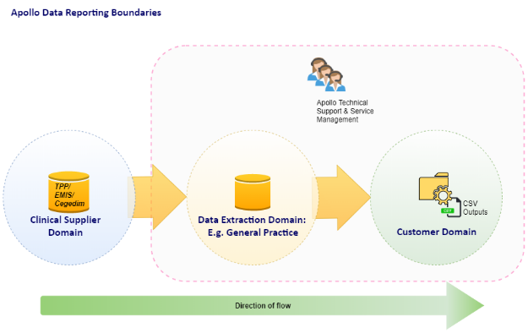

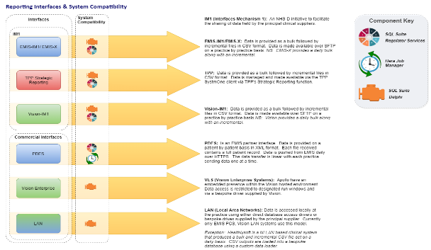

Apollo SQL is used by GPs across the UK to securely share specified data with customers including:RCGP/University of Surrey – Disease Monitoring >4m records twice weekly

* Northern Ireland flu surveillance and Diabetic Eye Screening Programme – All 330 practices in Northern Ireland daily extracts covering 1.9m patients
* North West London Collaboration – Integrated Care Programme or WISC (2m+ records)
* North East CSU – Risk Stratification Projects across London and other ICB areas.
* North West eHealth –Patient Recruitment and Clinical Research (Salford Lung Study)
* Outcomes Based Healthcare (OBH) – Monthly data extracts to support Population Health Management initiatives including population segmentation as well as outcome and HealthSpan® measurement.
* NHS England – GP Access and Appointment Tool
* NHS Digital – QoF Assessment

BCHC are offering to provide Apollo SQL at no cost to practices to support automated daily provision to CHIS of:

* Childhood immunisations
* 6 to 8 week medical exams

BCHC has carried out a full Data Protection Impact Assessment (DPIA) which is attached below, and we are assured that the provision of this data to CHIS via Apollo SQL is secure and fully complies with all relevant IG standards and legislation.

Before we directly offer this solution to any practice we are engaging with ICBs and LMCs to seek their approval and support to proceed with roll out including:

* IG approval for the proposed extraction process
* GP IT support with access for practices software installations (subject to the necessary approvals).

Once ICBs and LMCs have approved roll out then GPs will be able to register to use Apollo extraction service.

**How practices consent to set up the Apollo SQL data extractions for CHIS**

To consent to the processing and sharing of the specified data using Apollo SQL Practices will need to **review and sign the GP Practice Extraction Agreement through a DocuSign link** (Example [Docusign Link](https://eu.docusign.net/Member/PowerFormSigning.aspx?PowerFormId=d98fafd5-8abd-4e55-baa7-ada3f4fd24af&env=eu&acct=57df52f8-b5fb-46d5-ac32-65e74e09d224)).

GPs have full control over the extractions and can discontinue these at any time.

If you have any queries or would like to discuss any aspect of the new process your local CHIS Hub Manager will be happy to help.

**Mobilisation plan**

The high level actions we will be taking to mobilise Apollo SQL extractions of immunisations and 6 to 8 weeks exams are shown below:

|  |  |
| --- | --- |
| **ID** | **Action** |
| **1** | **Information Governance sign off** |
| **2** | **Practice configuration complete** |
| **3** | **Backend configuration complete** |
| **4** | **Piloting with test practices complete and signed off** |
| **5** | **BAU - all GPs are set up and providing extracts for daily CHIS updates & validations** |

We look forward to working closely with you as we implement this important improvement to the current process for electronic transfers of immunisation data.

Yours sincerely



Stephen Rawlings

Group Manager of Support Services

BCHC Children and Families Division

**Attachments**

|  |  |  |
| --- | --- | --- |
| **Number** | **Description** | **Attachment** |
| 1. | BCHC DPIA completed by DPO |  |
| 2. | IM1 Factsheet |  |
|  |  |  |