Kernow GPAS/OPEL escalation - key
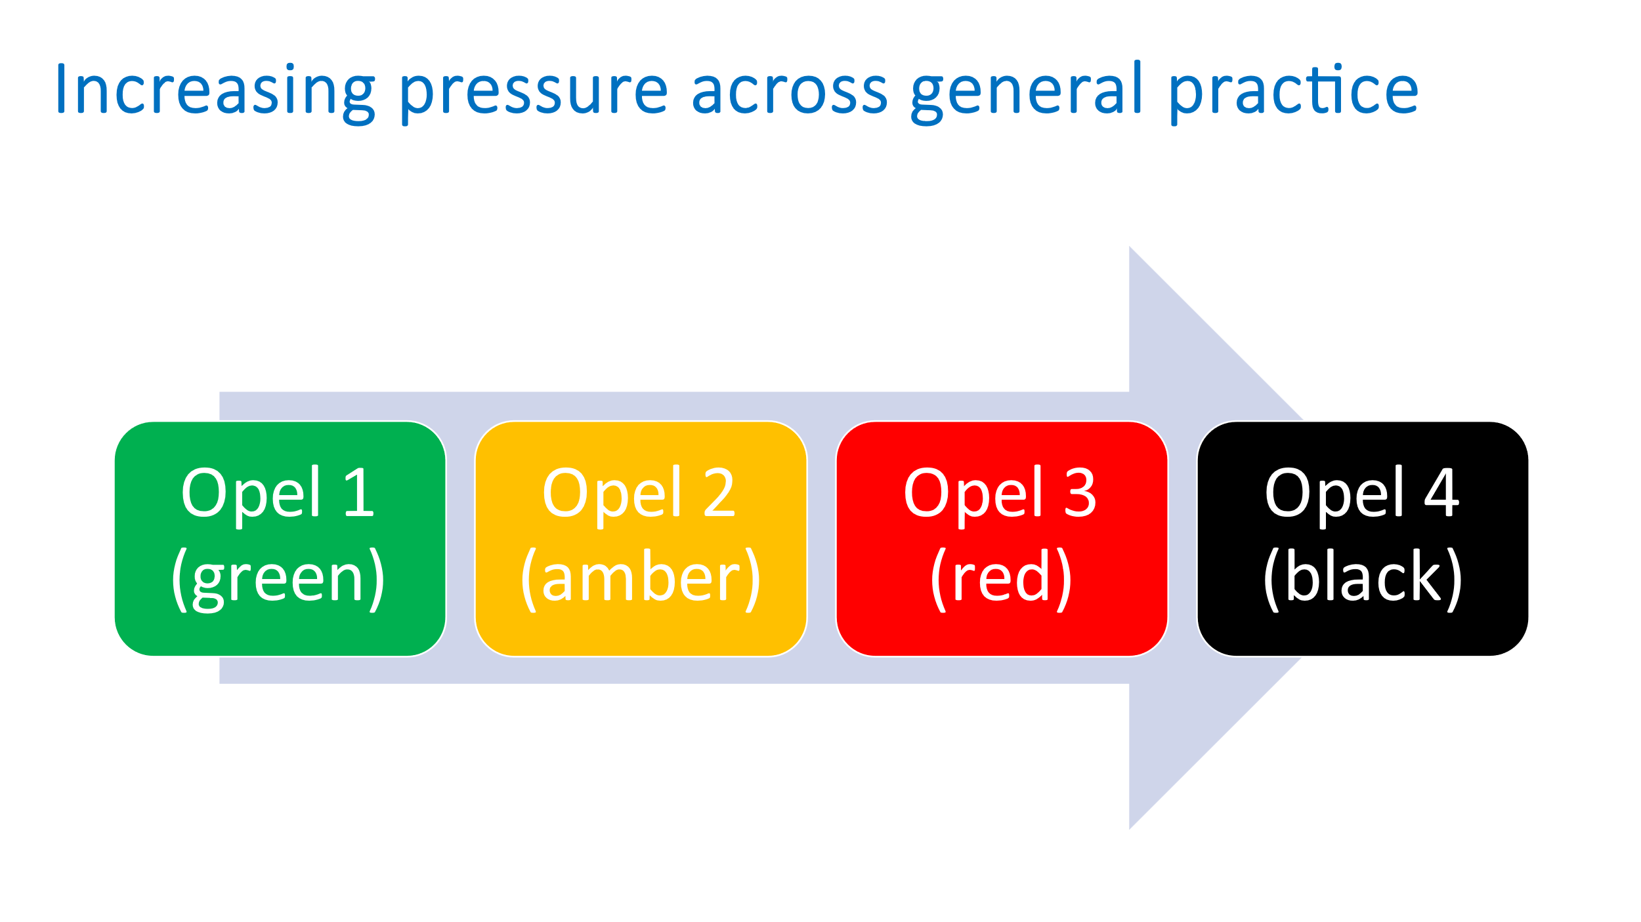
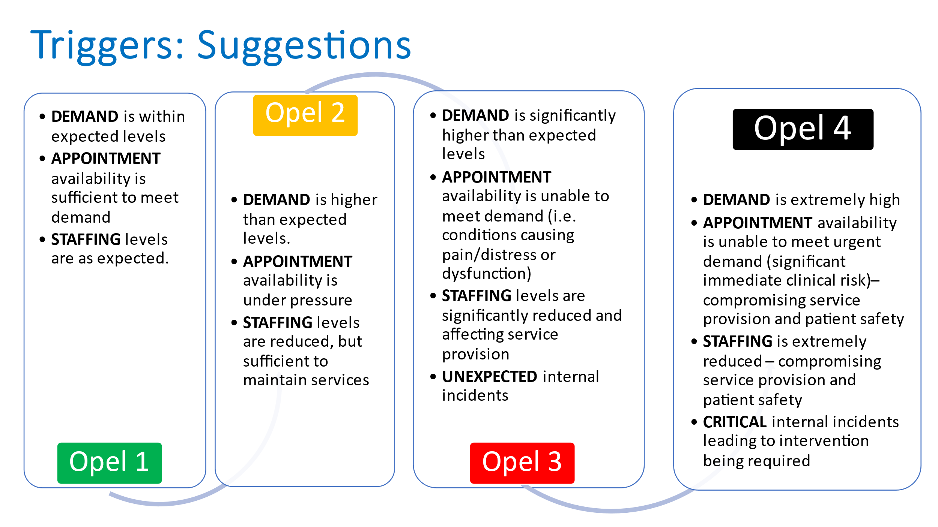

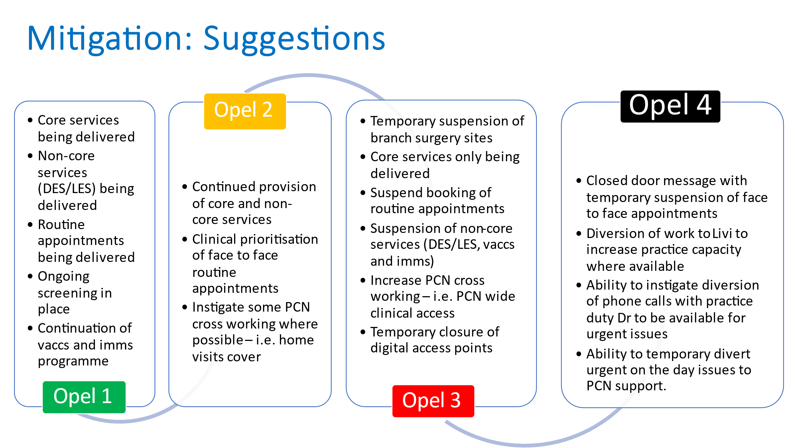
Alert State GREEN Overview OPEL 1
The GREEN state references a Practice running normally with resources largely in balance, patient waiting times are acceptable and communications with external stakeholders are at routine levels. The Green state is sustainable in the long term.
Key assessment criteria are:
Patient Flow | Demand Being met with waiting times at an acceptable level
Staff Levels | Balanced and Sustainable
Communications | At routine levels with stakeholders

Alert State AMBER Overview OPEL 2
The AMBER state references a Practice running with some staff/resource shortage, patient waiting times are acceptable and communications with external stakeholders are at slightly elevated levels. The Amber state is sustainable in the medium term only; management action is required to revert to the green state.
Key assessment criteria are:
Patient Flow | Waiting times extended but tolerable
Staff Levels | Some shortages but tolerable in the medium term
Communications | Increased level of communications with some stakeholders

Alert State RED Overview OPEL 3
The RED state references a Practice running safely under significant pressure but requiring immediate action to mitigate the situation. Staff shortages, increased patient waiting times and elevated levels of communications with stakeholders will have put the whole Practice under tenable strain. The Red state is sustainable only in the short term. Key assessment criteria are:
Key assessment criteria are:
Patient Flow | Compromised with insufficient bookable appointments and telephony possibly overwhelmed
Staff Levels | Shortages impacting upon operational delivery
Communications | Immediate communications required with stakeholders

Alert State BLACK Overview OPEL 4
The BLACK state references a Practice in distress. This state is unsafe to continue without intervention from stakeholders.
Key assessment criteria are:
Three assessment criteria at Alert State RED
No ability to revert to AMBER or GREEN in the short term.

